PROMETHEUS AND GRAFANA

Step 1 — Connect to Server
SSH into your Linux server:
ssh username@SERVER-IP
Example:
ssh ubuntu@192.168.1.10

Step 2 — Update Packages
For Ubuntu/Debian:
sudo apt update -y
sudo apt upgrade -y
For CentOS/RHEL/Rocky:
sudo yum update -y

Step 3 — Create Prometheus User
sudo useradd --no-create-home --shell /bin/false prometheus
Verify:
id prometheus

Step 4 — Create Directories
sudo mkdir /etc/prometheus
sudo mkdir /var/lib/prometheus
Set permissions:
sudo chown prometheus:prometheus /etc/prometheus
sudo chown prometheus:prometheus /var/lib/prometheus

Step 5 — Download Prometheus
Go to /tmp:
cd /tmp
Download:
wget https://github.com/prometheus/prometheus/releases/download/v3.4.2/prometheus-3.4.2.linux-amd64.tar.gz

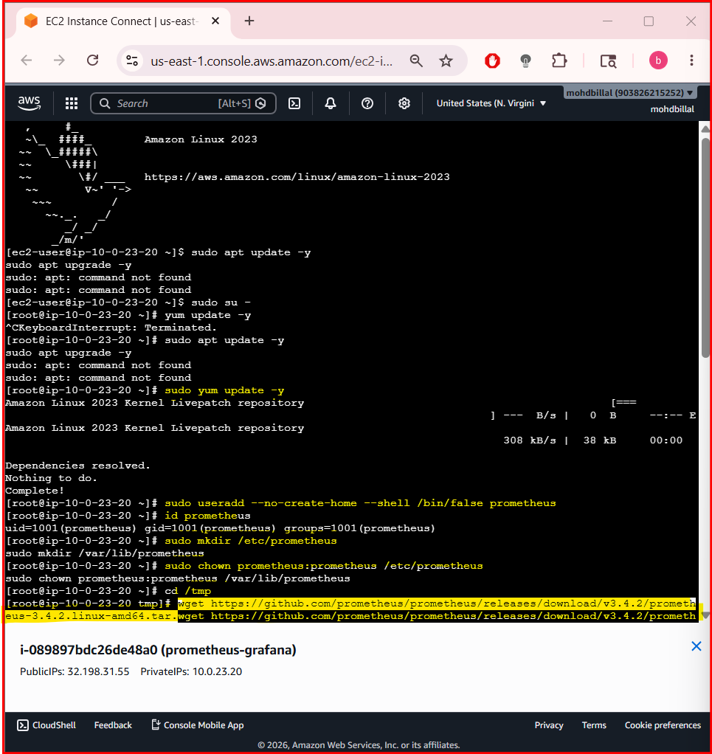
Extract:
tar -xvf prometheus-3.4.2.linux-amd64.tar.gz
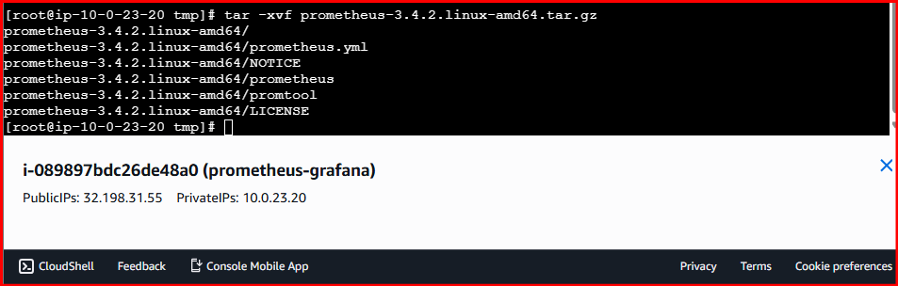
Enter folder:
cd prometheus-3.4.2.linux-amd64

Step 6 — Copy Files
Copy binaries:
sudo cp prometheus /usr/local/bin/
sudo cp promtool /usr/local/bin/
Copy config:
sudo cp prometheus.yml /etc/prometheus/
Copy console files:
sudo cp -r consoles /etc/prometheus
sudo cp -r console_libraries /etc/prometheus
Set ownership:
sudo chown -R prometheus:prometheus /etc/prometheus
sudo chown prometheus:prometheus /usr/local/bin/prometheus
sudo chown prometheus:prometheus /usr/local/bin/promtool
sudo chown -R prometheus:prometheus /var/lib/prometheus

Step 7 — Configure prometheus.yml
Open config file:
sudo nano /etc/prometheus/prometheus.yml

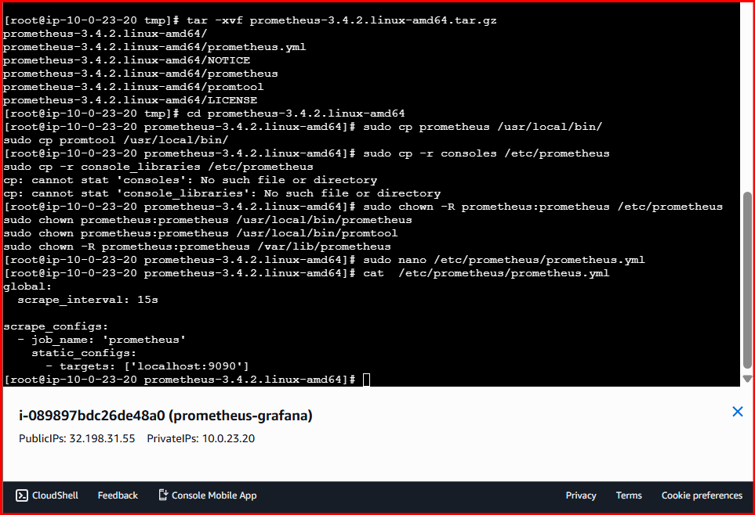
Paste:
global:
scrape_interval: 15s
scrape_configs:
- job_name: 'prometheus'
static_configs:
- targets: ['localhost:9090']
Save:
- CTRL + O
- Enter
- CTRL + X

Step 8 — Create Service File
sudo nano /etc/systemd/system/prometheus.service

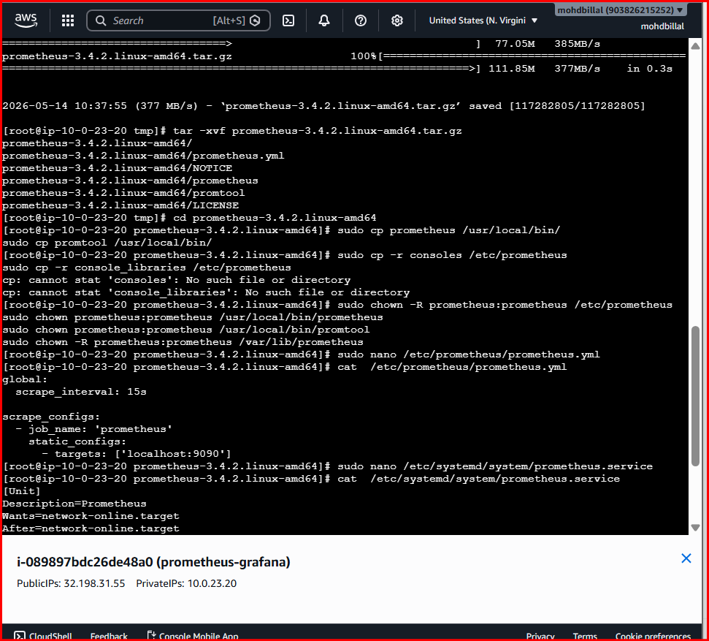
Paste:
[Unit]
Description=Prometheus
Wants=network-online.target
After=network-online.target
[Service]
User=prometheus
Group=prometheus
Type=simple
ExecStart=/usr/local/bin/prometheus \
--config.file=/etc/prometheus/prometheus.yml \
--storage.tsdb.path=/var/lib/prometheus \
--web.console.templates=/etc/prometheus/consoles \
--web.console.libraries=/etc/prometheus/console_libraries
[Install]
WantedBy=multi-user.target
Save and exit.

Step 9 — Reload Systemd
sudo systemctl daemon-reload

Step 10 — Enable Prometheus
sudo systemctl enable prometheus

Step 11 — Start Prometheus
sudo systemctl start prometheus

Step 12 — Check Status
sudo systemctl status prometheus
Expected output:
active (running)
Press:
Q
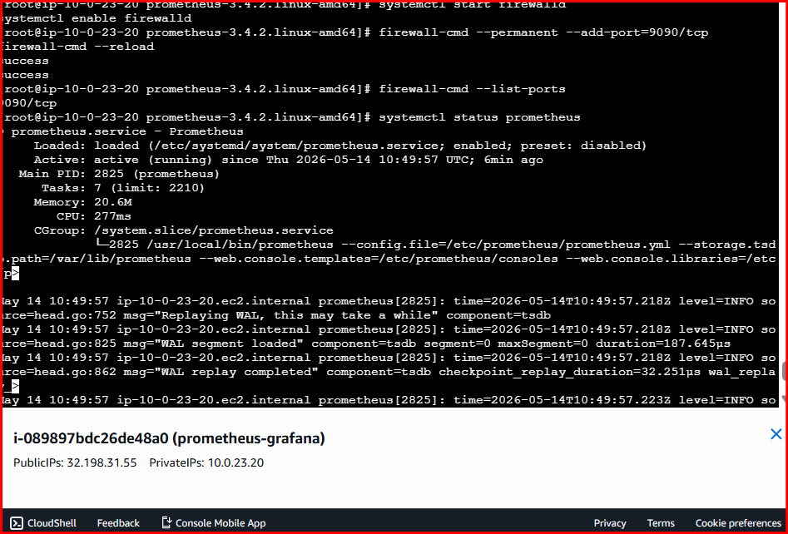

Step 13 — Open Port 9090
Ubuntu/Debian:
sudo ufw allow 9090/tcp
CentOS/RHEL:
sudo firewall-cmd --permanent --add-port=9090/tcp
sudo firewall-cmd --reload

Step 14 — Access Prometheus
Open browser:
http://SERVER-IP:9090
Example:
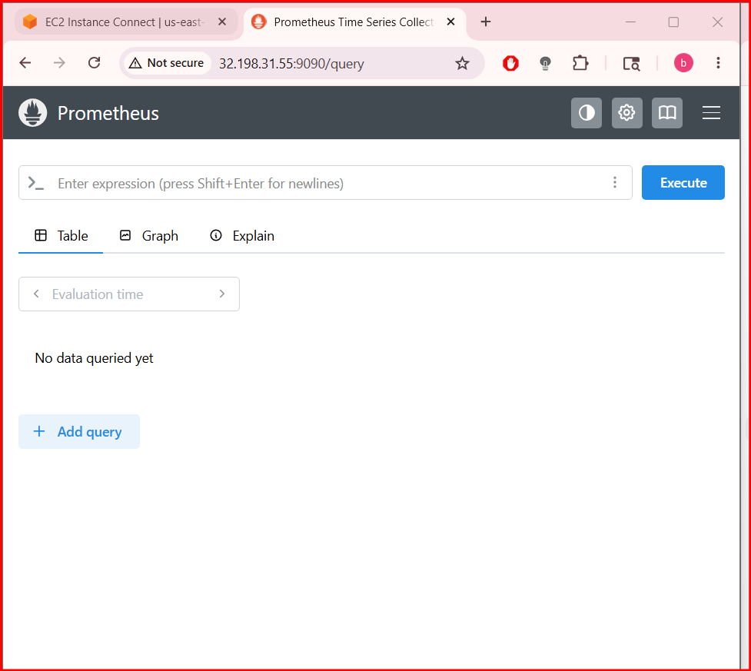
http://192.168.1.10:9090
You should see the Prometheus dashboard.

Step 15 — Install Node Exporter
Download:
cd /tmp
wget https://github.com/prometheus/node_exporter/releases/download/v1.9.1/node_exporter-1.9.1.linux-amd64.tar.gz
Extract:
tar -xvf node_exporter-1.9.1.linux-amd64.tar.gz
Enter folder:
cd node_exporter-1.9.1.linux-amd64
Copy binary:
sudo cp node_exporter /usr/local/bin/

Step 16 — Create Node Exporter User
sudo useradd --no-create-home --shell /bin/false node_exporter

Step 17 — Create Node Exporter Service
sudo nano /etc/systemd/system/node_exporter.service
Paste:
[Unit]
Description=Node Exporter
After=network.target
[Service]
User=node_exporter
Group=node_exporter
Type=simple
ExecStart=/usr/local/bin/node_exporter
[Install]
WantedBy=multi-user.target

Step 18 — Start Node Exporter
sudo systemctl daemon-reload
sudo systemctl enable node_exporter
sudo systemctl start node_exporter
Check status:
sudo systemctl status node_exporter

Step 19 — Add Node Exporter to Prometheus
Edit config:
sudo nano /etc/prometheus/prometheus.yml
Replace with:
global:
scrape_interval: 15s
scrape_configs:
- job_name: 'prometheus'
static_configs:
- targets: ['localhost:9090']
- job_name: 'node_exporter'
static_configs:
- targets: ['localhost:9100']

Step 20 — Restart Prometheus
sudo systemctl restart prometheus

Step 21 — Verify Targets
Open:
http://SERVER-IP:9090/targets
Both should show:
Up
2. Install and configure Node Exporter for system monitoring.

Step 1 — Create Node Exporter User
sudo useradd --no-create-home --shell /bin/false node_exporter
Verify:
id node_exporter

Step 2 — Download Node Exporter
Move to /tmp:
cd /tmp
Download latest version:
wget https://github.com/prometheus/node_exporter/releases/download/v1.9.1/node_exporter-1.9.1.linux-amd64.tar.gz

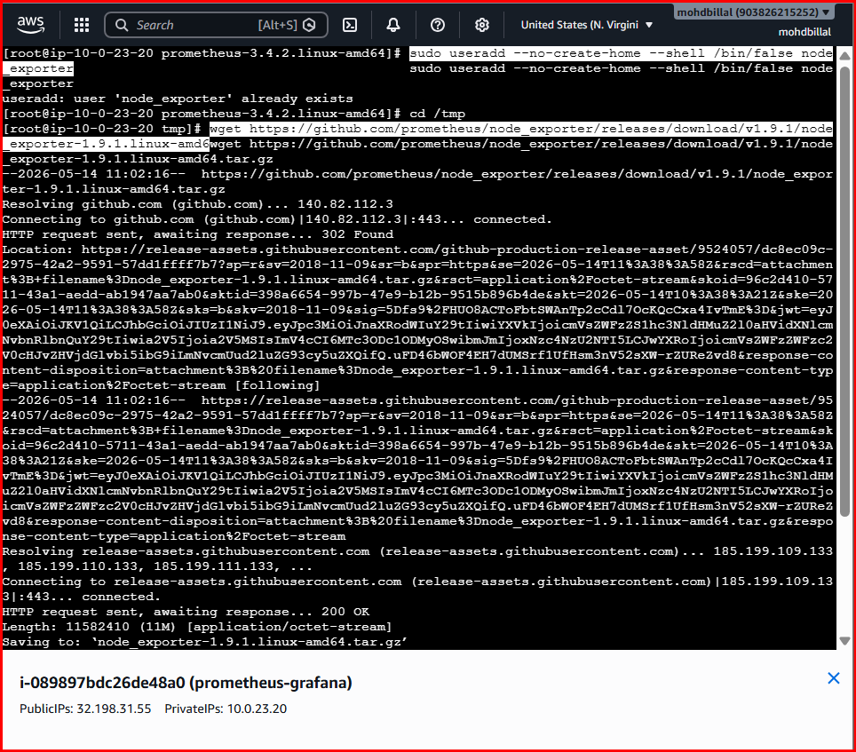

Step 3 — Extract File
tar -xvf node_exporter-1.9.1.linux-amd64.tar.gz
Go inside directory:
cd node_exporter-1.9.1.linux-amd64
Check files:
ls
You should see:
- node_exporter

Step 4 — Copy Binary
sudo cp node_exporter /usr/local/bin/
Set permissions:
sudo chown node_exporter:node_exporter /usr/local/bin/node_exporter

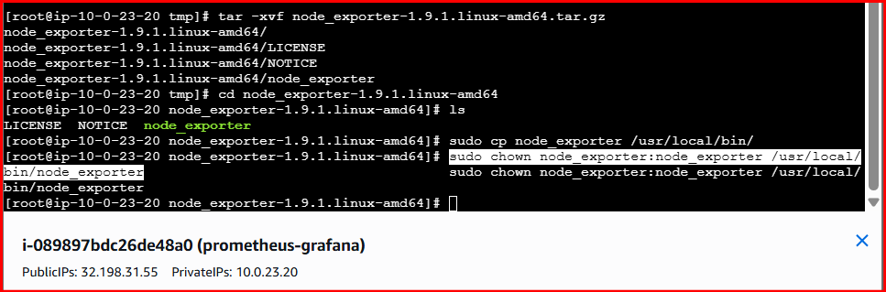

Step 5 — Create Systemd Service
Create service file:
sudo nano /etc/systemd/system/node_exporter.service
Paste this:
[Unit]
Description=Node Exporter
Wants=network-online.target
After=network-online.target
[Service]
User=node_exporter
Group=node_exporter
Type=simple
ExecStart=/usr/local/bin/node_exporter
[Install]
WantedBy=multi-user.target
Save:
- CTRL + O
- Enter
- CTRL + X

Step 6 — Reload Systemd
sudo systemctl daemon-reload

Step 7 — Enable Node Exporter
sudo systemctl enable node_exporter

Step 8 — Start Node Exporter
sudo systemctl start node_exporter

Step 9 — Check Status
sudo systemctl status node_exporter
You should see:
active (running)
Exit:
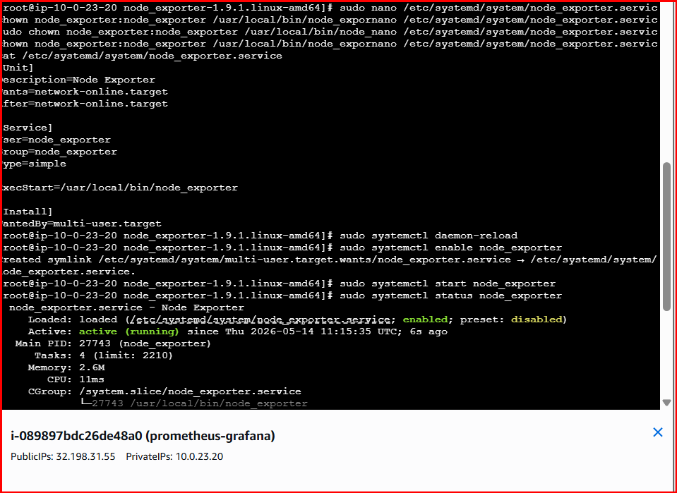
q

Step 10 — Open Port 9100
If using firewalld:
sudo firewall-cmd --permanent --add-port=9100/tcp
sudo firewall-cmd --reload
Verify:
sudo firewall-cmd --list-ports

Step 11 — Verify Node Exporter
Open browser:
http://SERVER-IP:9100/metrics
You should see lots of metrics like:
node_cpu_seconds_total
node_memory_MemAvailable_bytes
node_filesystem_size_bytes

Step 12 — Configure Prometheus
Edit Prometheus config:
sudo nano /etc/prometheus/prometheus.yml
Add Node Exporter section:
global:
scrape_interval: 15s
scrape_configs:
- job_name: 'prometheus'
static_configs:
- targets: ['localhost:9090']
- job_name: 'node_exporter'
static_configs:
- targets: ['localhost:9100']
Save and exit.

Step 13 — Restart Prometheus
sudo systemctl restart prometheus

Step 14 — Verify in Prometheus
Open:
http://SERVER-IP:9090/targets
You should see:
Job | State
prometheus | UP
node_exporter | UP

Useful Metrics Queries
Open Prometheus UI → Graph tab.
CPU Usage:
100 - (avg by(instance) (rate(node_cpu_seconds_total{mode="idle"}[5m])) * 100)
Memory Usage:
(node_memory_MemTotal_bytes - node_memory_MemAvailable_bytes) / node_memory_MemTotal_bytes * 100
Disk Usage:
(node_filesystem_size_bytes - node_filesystem_free_bytes) / node_filesystem_size_bytes * 100

Official Resources
- Node Exporter GitHub
- Prometheus Official Website
sudo systemctl restart prometheus
failed to start
Check why the Prometheus service failed.
Run this command:
sudo systemctl status prometheus -l
Then check detailed logs:
sudo journalctl -u prometheus --no-pager -n 50
Most common issue is syntax error in prometheus.yml.
Validate config:
sudo /usr/local/bin/promtool check config /etc/prometheus/prometheus.yml
If configuration is correct, you should see:
SUCCESS: /etc/prometheus/prometheus.yml is valid prometheus config file syntax
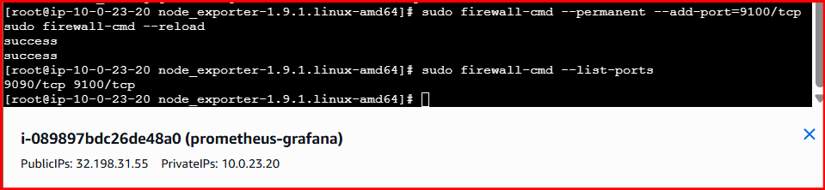

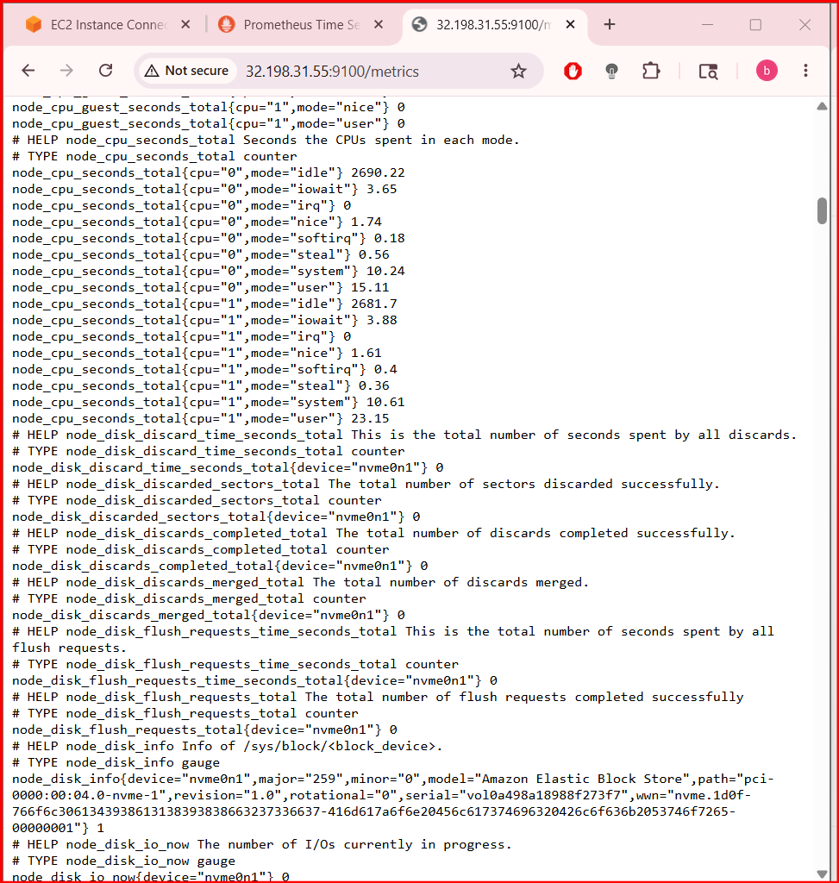
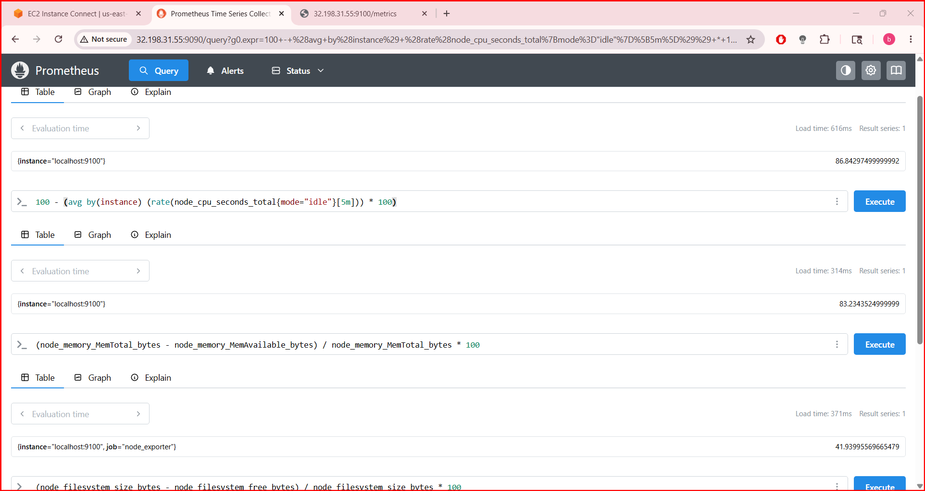
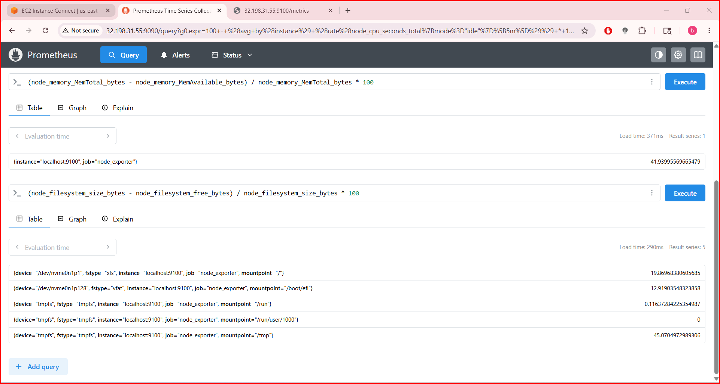

3. Set up SNMP Exporter to monitor network devices.

Architecture
Network Device ---> SNMP Exporter ---> Prometheus

Step 1 — Create SNMP Exporter User
sudo useradd --no-create-home --shell /bin/false snmp_exporter

Step 2 — Download SNMP Exporter
Move to /tmp:
cd /tmp
Download latest release:
wget https://github.com/prometheus/snmp_exporter/releases/download/v0.29.0/snmp_exporter-0.29.0.linux-amd64.tar.gz

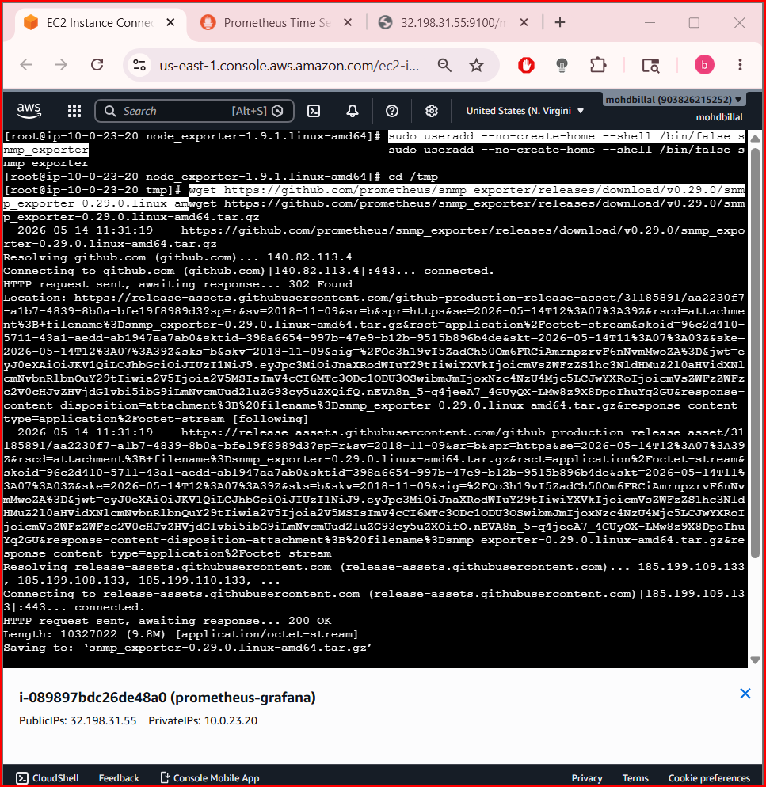
Extract:
tar -xvf snmp_exporter-0.29.0.linux-amd64.tar.gz
Enter directory:
cd snmp_exporter-0.29.0.linux-amd64
Check files:
ls
You should see:
- snmp_exporter
- snmp.yml

Step 3 — Create Directories
sudo mkdir /etc/snmp_exporter

Step 4 — Copy Files
Copy binary:
sudo cp snmp_exporter /usr/local/bin/
Copy config:
sudo cp snmp.yml /etc/snmp_exporter/
Set permissions:
sudo chown -R snmp_exporter:snmp_exporter /etc/snmp_exporter
sudo chown snmp_exporter:snmp_exporter /usr/local/bin/snmp_exporter
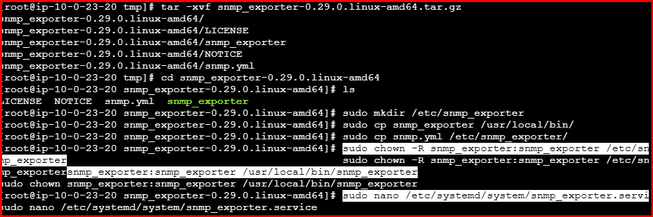

Step 5 — Create Systemd Service
Create service file:
sudo nano /etc/systemd/system/snmp_exporter.service
Paste:
[Unit]
Description=SNMP Exporter
Wants=network-online.target
After=network-online.target
[Service]
User=snmp_exporter
Group=snmp_exporter
Type=simple
ExecStart=/usr/local/bin/snmp_exporter \
--config.file=/etc/snmp_exporter/snmp.yml
[Install]
WantedBy=multi-user.target
Save and exit.

Step 6 — Reload Systemd
sudo systemctl daemon-reload

Step 7 — Enable Service
sudo systemctl enable snmp_exporter

Step 8 — Start SNMP Exporter
sudo systemctl start snmp_exporter

Step 9 — Check Status
sudo systemctl status snmp_exporter
You should see:
active (running)
Exit:
Q
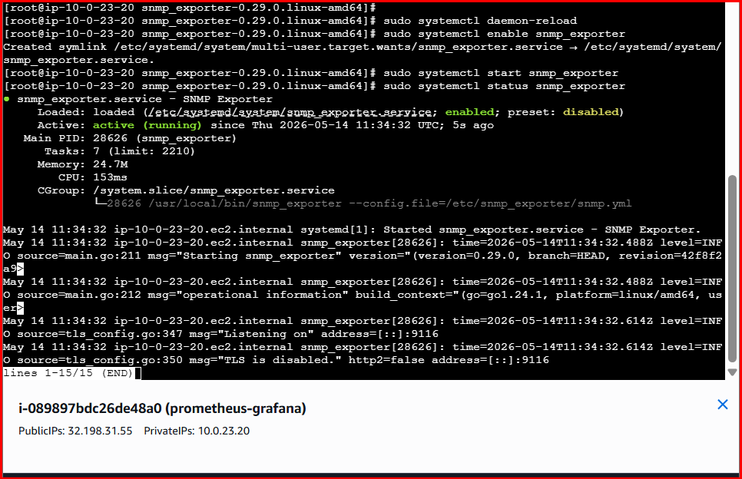

Step 10 — Open Port 9116
If using firewalld:
sudo firewall-cmd --permanent --add-port=9116/tcp
sudo firewall-cmd --reload
Verify:
sudo firewall-cmd --list-ports
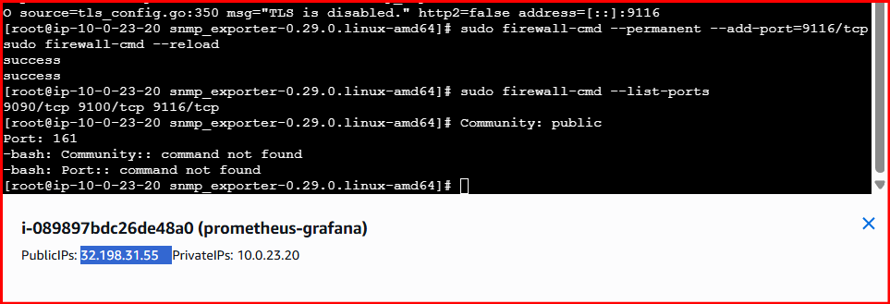

Step 11 — Configure Network Device
Enable SNMP on your router/switch/firewall.
Example SNMP v2 community:
Community: public
Port: 161
Device examples:
- Cisco Router
- Juniper Networks Switch
- MikroTik Router

Step 12 — Test SNMP Exporter
Open browser:
http://SERVER-IP:9116
You should see SNMP Exporter page.
Test metrics:
http://SERVER-IP:9116/snmp?module=if_mib&target=DEVICE-IP
Example:
http://192.168.1.10:9116/snmp?module=if_mib&target=192.168.1.1
If successful, you’ll see metrics.
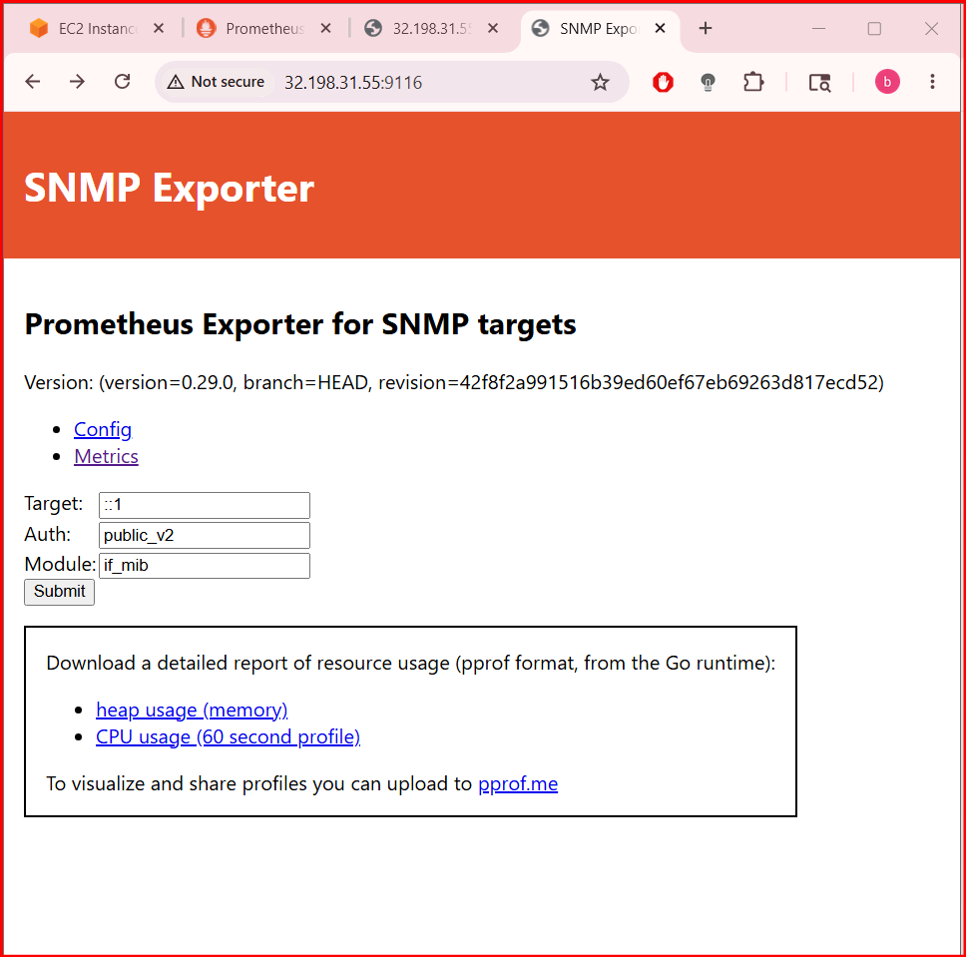

Step 13 — Configure Prometheus
Edit Prometheus config:
sudo nano /etc/prometheus/prometheus.yml
Add SNMP Exporter job:
- job_name: 'snmp'
metrics_path: /snmp
params:
module: [if_mib]
static_configs:
- targets:
- 192.168.1.1
relabel_configs:
- source_labels: [__address__]
target_label: __param_target
- source_labels: [__param_target]
target_label: instance
- target_label: __address__
replacement: localhost:9116
Replace:
- 192.168.1.1 with your network device IP

Full Example prometheus.yml
global:
scrape_interval: 15s
scrape_configs:
- job_name: 'prometheus'
static_configs:
- targets: ['localhost:9090']
- job_name: 'node_exporter'
static_configs:
- targets: ['localhost:9100']
- job_name: 'snmp'
metrics_path: /snmp
params:
module: [if_mib]
static_configs:
- targets:
- 192.168.1.1
relabel_configs:
- source_labels: [__address__]
target_label: __param_target
- source_labels: [__param_target]
target_label: instance
- target_label: __address__
replacement: localhost:9116

Step 14 — Validate Configuration
sudo promtool check config /etc/prometheus/prometheus.yml
Expected:
SUCCESS

Step 15 — Restart Prometheus
sudo systemctl restart Prometheus

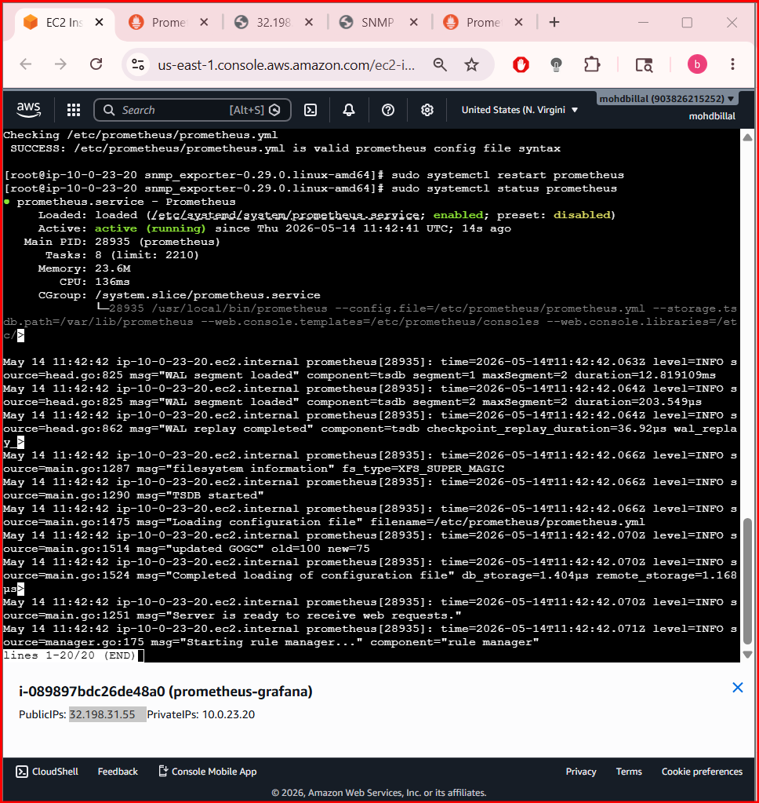

Step 16 — Verify Targets
Open:
http://SERVER-IP:9090/targets
You should see:
- prometheus → UP
- node_exporter → UP
- snmp → UP

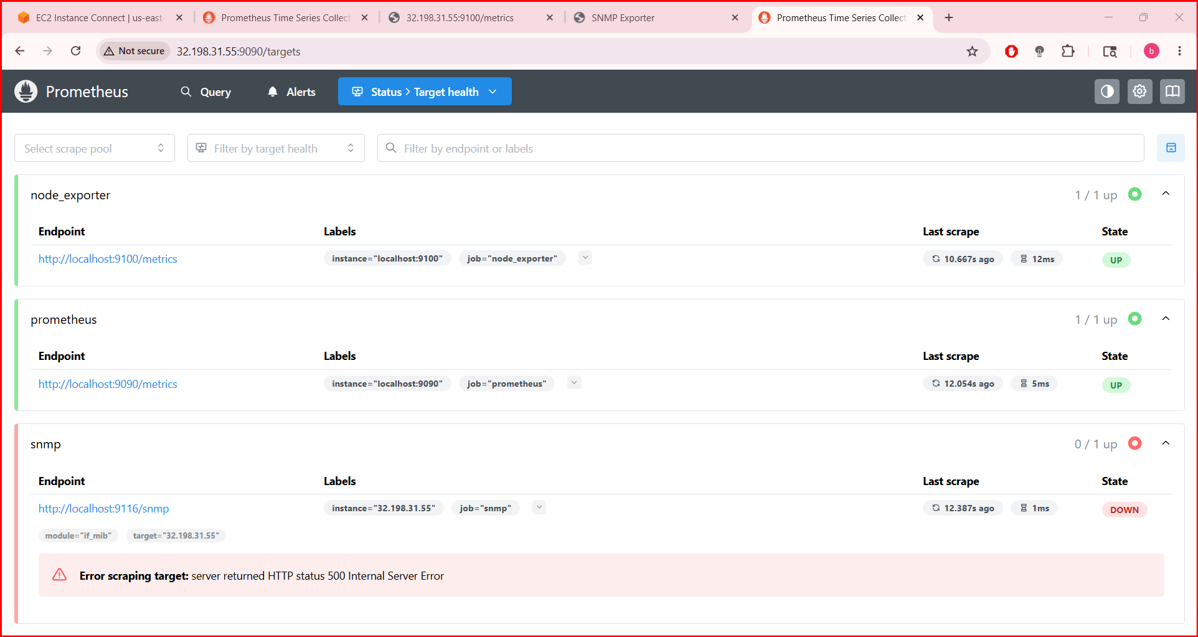

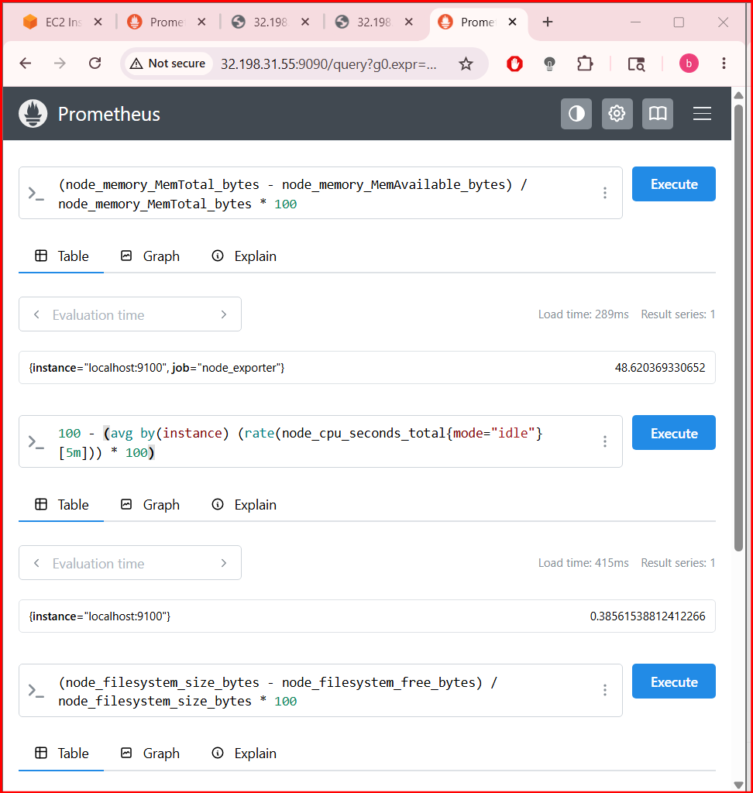

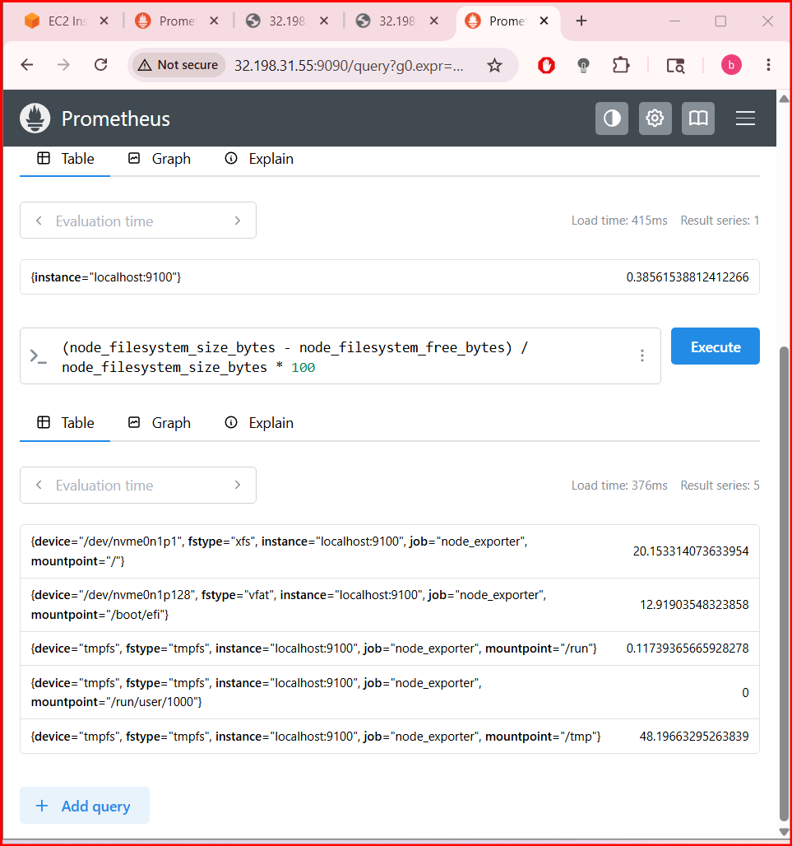

  - Set up Prometheus to run as a systemd service for automatic startup.

Step 1 — Verify Prometheus Binary
Check if Prometheus exists:
ls /usr/local/bin/prometheus
If file exists, continue.
If not, copy it:
sudo cp prometheus /usr/local/bin/

Step 2 — Create Prometheus User
sudo useradd --no-create-home --shell /bin/false prometheus
If user already exists, ignore the warning.

Step 3 — Create Required Directories
sudo mkdir -p /etc/prometheus
sudo mkdir -p /var/lib/prometheus
Set ownership:
sudo chown -R prometheus:prometheus /etc/prometheus
sudo chown -R prometheus:prometheus /var/lib/prometheus

Step 4 — Create Prometheus Service File
Open service file:
sudo nano /etc/systemd/system/prometheus.service
Paste this configuration:
[Unit]
Description=Prometheus Monitoring
Wants=network-online.target
After=network-online.target
[Service]
User=prometheus
Group=prometheus
Type=simple
ExecStart=/usr/local/bin/prometheus \
--config.file=/etc/prometheus/prometheus.yml \
--storage.tsdb.path=/var/lib/prometheus \
--web.console.templates=/etc/prometheus/consoles \
--web.console.libraries=/etc/prometheus/console_libraries
Restart=always
[Install]
WantedBy=multi-user.target
Save:
- CTRL + O
- Enter
- CTRL + X

Step 5 — Reload Systemd
sudo systemctl daemon-reload

Step 6 — Enable Automatic Startup
sudo systemctl enable prometheus
Expected output:
Created symlink ...

Step 7 — Start Prometheus Service
sudo systemctl start prometheus

Step 8 — Check Service Status
sudo systemctl status prometheus
Expected:
active (running)
Press:
Q
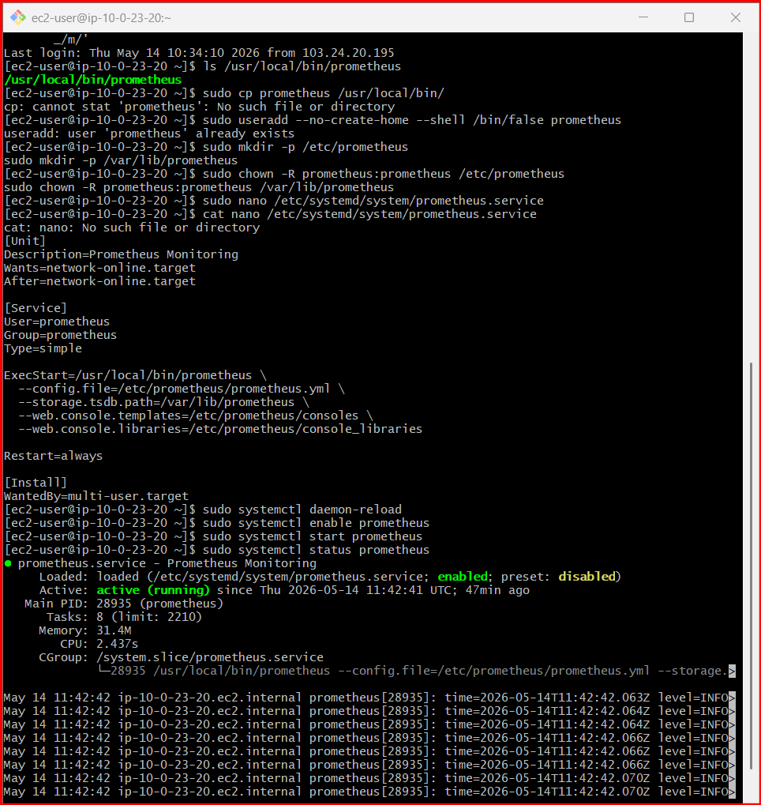

Step 9 — Verify Automatic Startup
Check if enabled:
sudo systemctl is-enabled prometheus
Expected:
enabled

Step 10 — Test After Reboot
Reboot server:
sudo reboot
Reconnect after reboot and verify:
sudo systemctl status prometheus
Prometheus should automatically start.

Useful Service Commands
Start:
sudo systemctl start prometheus
Stop:
sudo systemctl stop prometheus
Restart:
sudo systemctl restart prometheus
View logs:
sudo journalctl -u prometheus –f

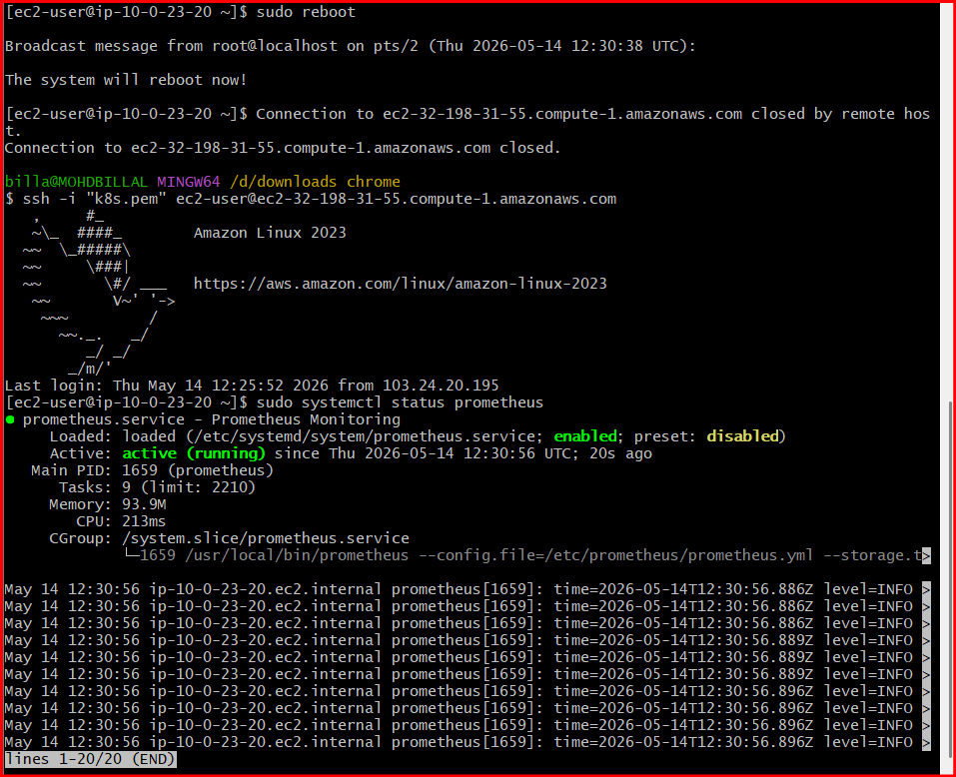

Verify Prometheus in Browser
Open:
http://SERVER-IP:9090
You should see the Prometheus dashboar

  - Install Alertmanager and configure an email alert.

Architecture
Prometheus ---> Alertmanager ---> Email

Step 1 — Create Alertmanager User
sudo useradd --no-create-home --shell /bin/false alertmanager
Verify:
id alertmanager

Step 2 — Create Directories
sudo mkdir /etc/alertmanager
sudo mkdir /var/lib/alertmanager
Set permissions:
sudo chown -R alertmanager:alertmanager /etc/alertmanager
sudo chown -R alertmanager:alertmanager /var/lib/alertmanager

Step 3 — Download Alertmanager
Move to /tmp:
cd /tmp
Download:
wget https://github.com/prometheus/alertmanager/releases/download/v0.28.1/alertmanager-0.28.1.linux-amd64.tar.gz

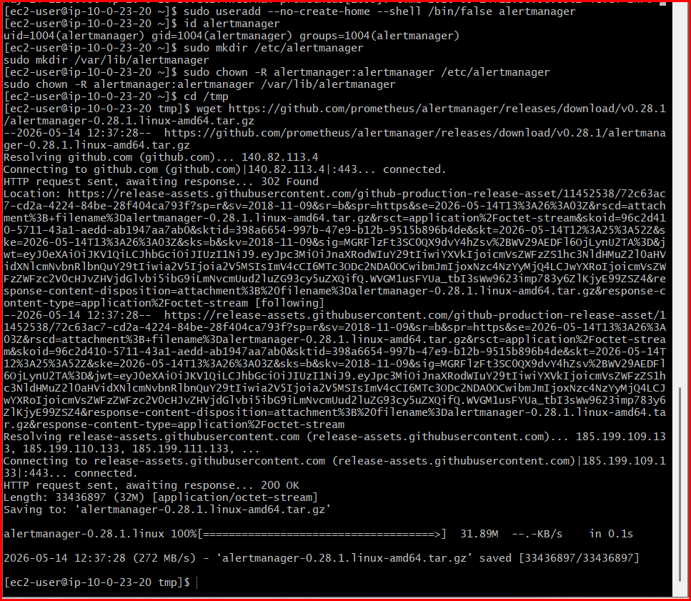
Extract:
tar -xvf alertmanager-0.28.1.linux-amd64.tar.gz
Enter directory:
cd alertmanager-0.28.1.linux-amd64
Check files:
ls
You should see:
- alertmanager
- amtool
- alertmanager.yml

Step 4 — Copy Files
Copy binaries:
sudo cp alertmanager /usr/local/bin/
sudo cp amtool /usr/local/bin/
Copy config:
sudo cp alertmanager.yml /etc/alertmanager/
Set ownership:
sudo chown alertmanager:alertmanager /usr/local/bin/alertmanager
sudo chown alertmanager:alertmanager /usr/local/bin/amtool
sudo chown -R alertmanager:alertmanager /etc/alertmanager

Step 5 — Configure Email Alerts
Open config:
sudo nano /etc/alertmanager/alertmanager.yml
Replace everything with:
global:
smtp_smarthost: 'smtp.gmail.com:587'
smtp_from: 'YOUR_GMAIL@gmail.com'
smtp_auth_username: 'YOUR_GMAIL@gmail.com'
smtp_auth_password: 'YOUR_APP_PASSWORD'
route:
receiver: 'email-alert'
receivers:
- name: 'email-alert'
email_configs:
- to: 'receiver@gmail.com'
from: 'YOUR_GMAIL@gmail.com'
smarthost: 'smtp.gmail.com:587'
auth_username: 'YOUR_GMAIL@gmail.com'
auth_identity: 'YOUR_GMAIL@gmail.com'
auth_password: 'YOUR_APP_PASSWORD'
Replace:
- YOUR_GMAIL@gmail.com
- YOUR_APP_PASSWORD
- receiver@gmail.com
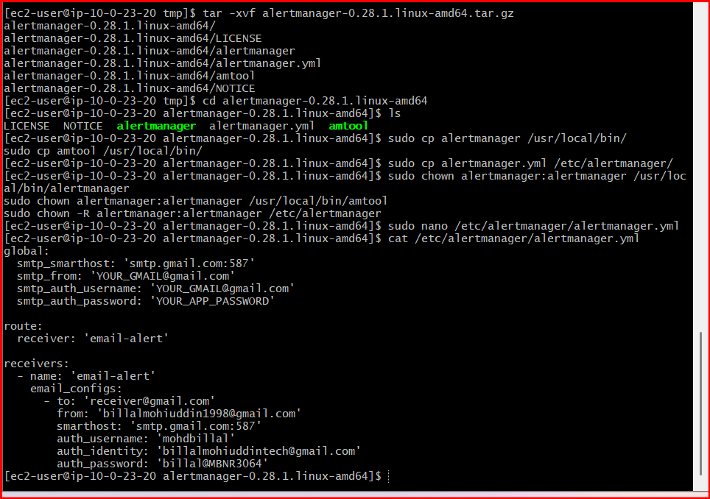

Important for Gmail
You must create a Gmail App Password.
Open:
Google App Passwords
Steps:
- Enable 2-Step Verification
- Create App Password
- Use generated password in smtp_auth_password

Step 6 — Validate Alertmanager Config
Run:
amtool check-config /etc/alertmanager/alertmanager.yml
Expected:
SUCCESS

Step 7 — Create Systemd Service
Create service file:
sudo nano /etc/systemd/system/alertmanager.service
Paste:
[Unit]
Description=Alertmanager
Wants=network-online.target
After=network-online.target
[Service]
User=alertmanager
Group=alertmanager
Type=simple
ExecStart=/usr/local/bin/alertmanager \
--config.file=/etc/alertmanager/alertmanager.yml \
--storage.path=/var/lib/alertmanager
Restart=always
[Install]
WantedBy=multi-user.target
Save and exit.

Step 8 — Reload Systemd
sudo systemctl daemon-reload

Step 9 — Enable Alertmanager
sudo systemctl enable alertmanager

Step 10 — Start Alertmanager
sudo systemctl start alertmanager

Step 11 — Check Status
sudo systemctl status alertmanager
Expected:
active (running)
Exit:
Q
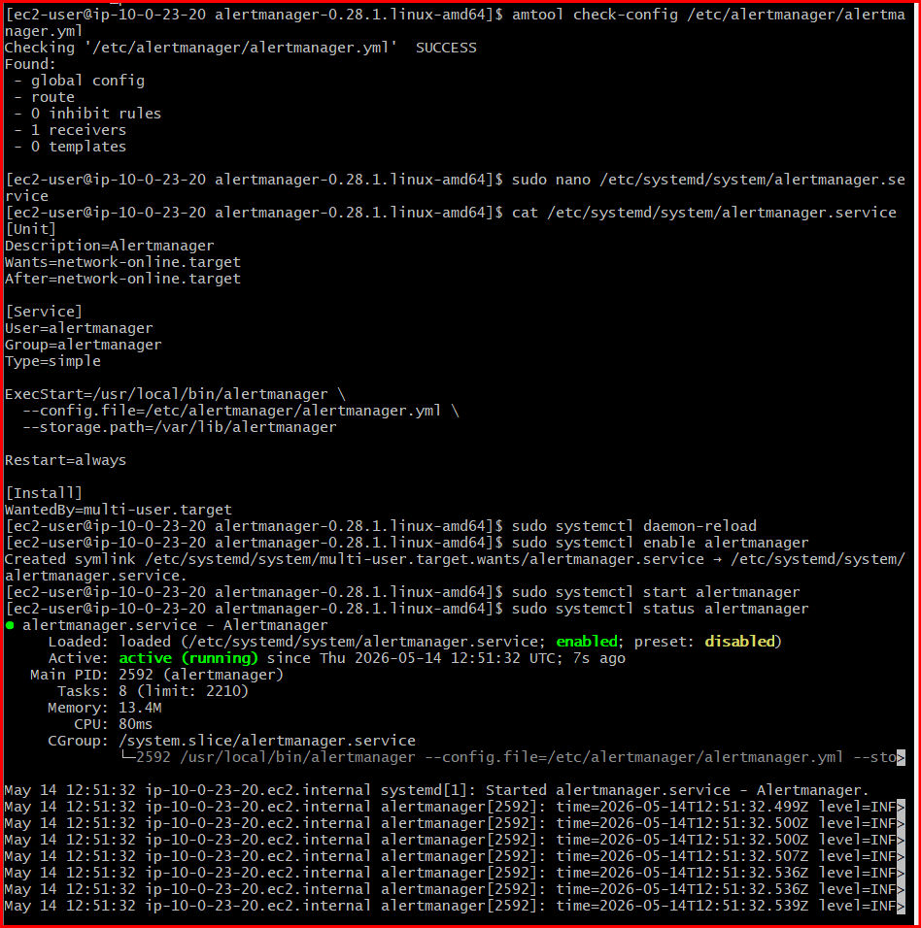

Step 12 — Open Port 9093
If using firewalld:
sudo firewall-cmd --permanent --add-port=9093/tcp
sudo firewall-cmd --reload

Step 13 — Access Alertmanager
Open browser:
http://SERVER-IP:9093
You should see Alertmanager dashboard.
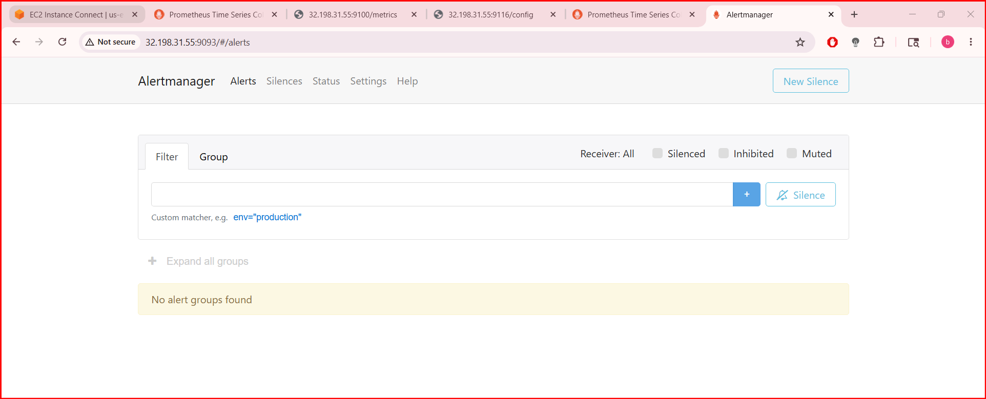

Step 14 — Connect Prometheus to Alertmanager
Edit Prometheus config:
sudo nano /etc/prometheus/prometheus.yml
Add this section:
alerting:
alertmanagers:
- static_configs:
- targets:
- localhost:9093
Example full config:
global:
scrape_interval: 15s
alerting:
alertmanagers:
- static_configs:
- targets:
- localhost:9093
scrape_configs:
- job_name: 'prometheus'
static_configs:
- targets: ['localhost:9090']

Step 15 — Create Alert Rules
Create rules file:
sudo nano /etc/prometheus/alert.rules.yml
Paste:
groups:
- name: LinuxServerAlert
rules:
- alert: InstanceDown
expr: up == 0
for: 1m
labels:
severity: critical
annotations:
summary: "Instance Down"
description: "Server has been down for more than 1 minute."
Save and exit.

Step 16 — Add Rule File in Prometheus
Edit config again:
sudo nano /etc/prometheus/prometheus.yml
Add:
rule_files:
- "alert.rules.yml"
Example:
global:
scrape_interval: 15s
rule_files:
- "alert.rules.yml"
alerting:
alertmanagers:
- static_configs:
- targets:
- localhost:9093
scrape_configs:
- job_name: 'prometheus'
static_configs:
- targets: ['localhost:9090']

Step 17 — Validate Prometheus Config
promtool check config /etc/prometheus/prometheus.yml
Expected:
SUCCESS

Step 18 — Restart Prometheus
sudo systemctl restart prometheus

Step 19 — Verify Alerts
Open:
http://SERVER-IP:9090/alerts
You will see configured alerts.

Step 20 — Test Email Alert
Stop Node Exporter temporarily:
sudo systemctl stop node_exporter

  - Install Grafana and add Prometheus as a data source.

Step 1 — Create Grafana Repository
Since your server appears to be RHEL/CentOS/Amazon Linux based, create Grafana repo.
Create repo file:
sudo nano /etc/yum.repos.d/grafana.repo
Paste:
[grafana]
name=Grafana OSS
baseurl=https://rpm.grafana.com
repo_gpgcheck=1
enabled=1
gpgcheck=1
gpgkey=https://rpm.grafana.com/gpg.key
sslverify=1
sslcacert=/etc/pki/tls/certs/ca-bundle.crt
Save and exit.

Step 2 — Install Grafana
sudo yum install grafana –y
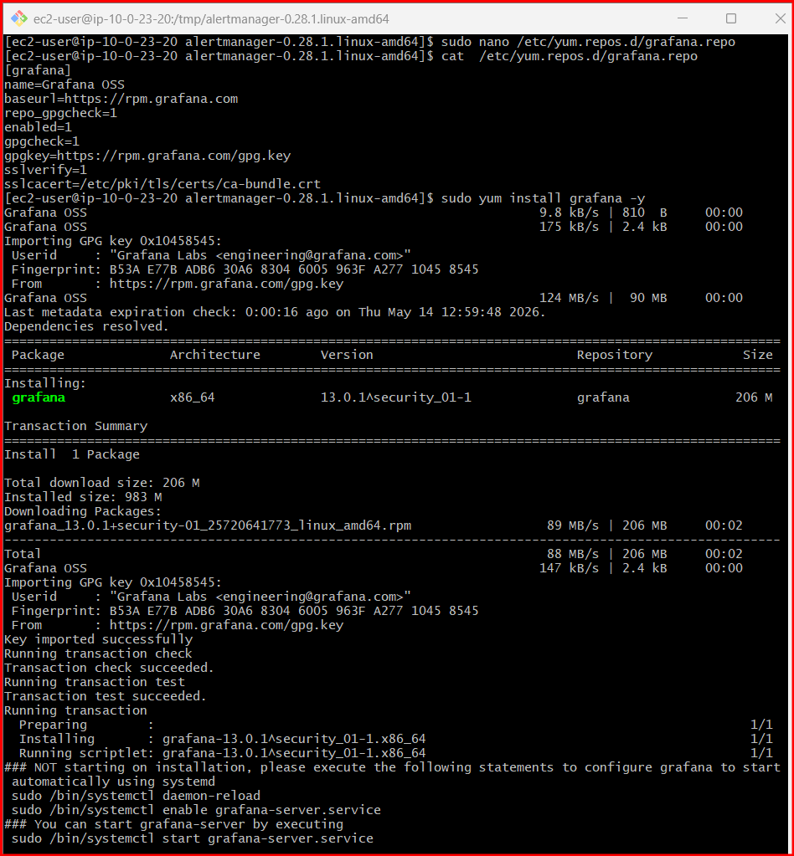

Step 3 — Reload Systemd
sudo systemctl daemon-reload

Step 4 — Enable Grafana
sudo systemctl enable grafana-server

Step 5 — Start Grafana
sudo systemctl start grafana-server

Step 6 — Check Status
sudo systemctl status grafana-server
You should see:
active (running)
Exit:
Q

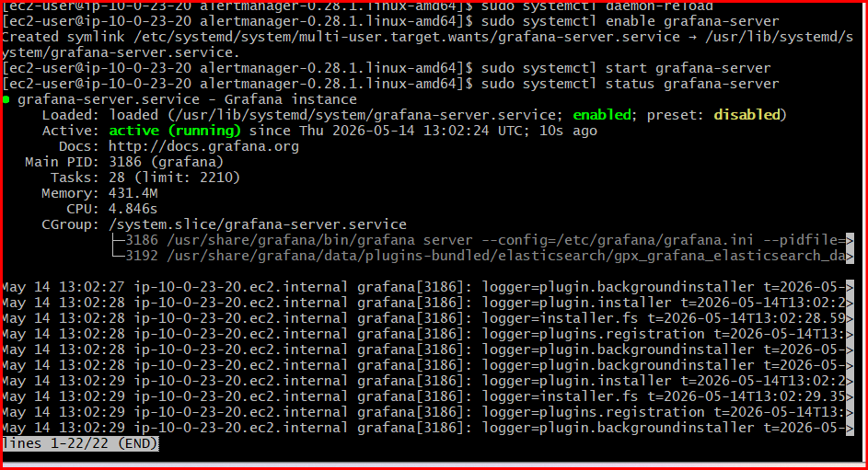

Step 7 — Open Grafana Port
Grafana runs on port 3000.
Allow port:
sudo firewall-cmd --permanent --add-port=3000/tcp
sudo firewall-cmd --reload
Verify:
sudo firewall-cmd --list-ports

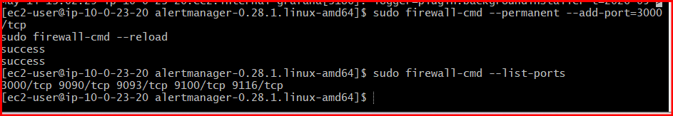
You should see:
3000/tcp

Step 8 — Access Grafana
Open browser:
http://SERVER-IP:3000
Example:
http://192.168.1.10:3000

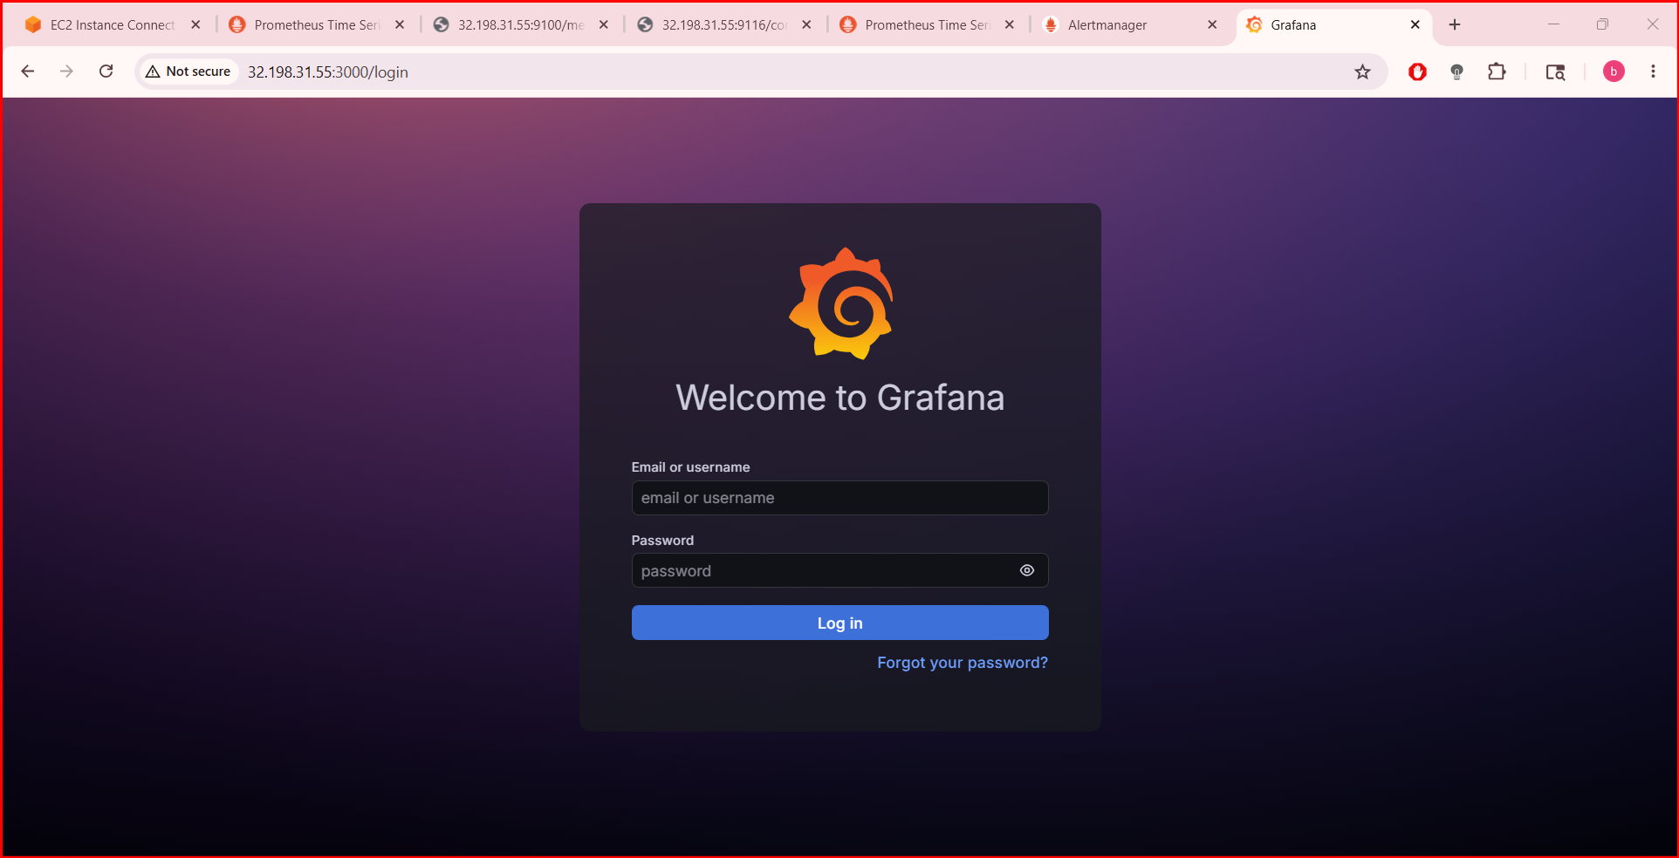

Step 9 — Login to Grafana
Default credentials:
Username: admin
Password: admin
Grafana will ask you to change password.

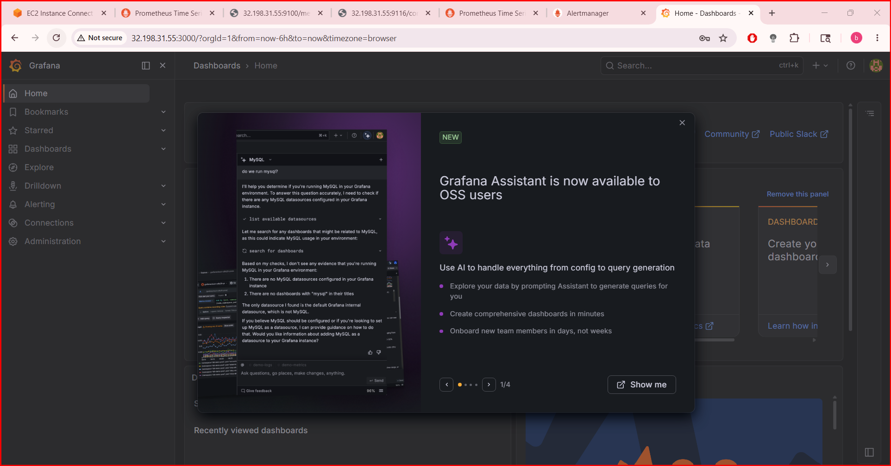

Step 10 — Add Prometheus Data Source
In Grafana UI:
- Click ⚙️ Settings
- Click Data Sources
- Click Add data source
- Select Prometheus

Step 11 — Configure Prometheus
In URL field enter:
http://localhost:9090
OR
http://PROMETHEUS-SERVER-IP:9090
Then click:
Save & Test
Expected message:
Data source is working

Step 12 — Import Node Exporter Dashboard
Grafana has ready-made dashboards.
Click:
- ➕ Create
- Import
Dashboard ID:
1860
This is popular Node Exporter dashboard.
Click:
Load
Select Prometheus data source.
Click:
Import
You’ll now see:
- CPU usage
- RAM usage
- Disk usage
- Network usage
from Node Exporter.

Step 13 — Verify Metrics
Open Prometheus:
http://SERVER-IP:9090
Test query:
up
If metrics appear, Grafana dashboards will work.

Useful Grafana Commands
Restart Grafana:
sudo systemctl restart grafana-server
View logs:
sudo journalctl -u grafana-server -f
Stop Grafana:
sudo systemctl stop grafana-server

  - Configure Prometheus for service discovery of dynamic targets.

Step 1 — Create Discovery Directory
sudo mkdir -p /etc/prometheus/file_sd
Set permissions:
sudo chown -R prometheus:prometheus /etc/prometheus/file_sd

Step 2 — Create Dynamic Targets File
Create JSON file:
sudo nano /etc/prometheus/file_sd/targets.json
Paste:
[
{
"targets": [
"localhost:9100",
"192.168.1.20:9100",
"192.168.1.21:9100"
],
"labels": {
"env": "production",
"job": "node_exporter"
}
}
]
Replace IPs with your servers.
Save and exit.

Step 3 — Configure prometheus.yml
Edit config:
sudo nano /etc/prometheus/prometheus.yml
Add this scrape job:
- job_name: 'dynamic_nodes'
file_sd_configs:
- files:
- /etc/prometheus/file_sd/*.json
relabel_configs:
- source_labels: [__address__]
target_label: instance

Full Example prometheus.yml
global:
scrape_interval: 15s
scrape_configs:
- job_name: 'prometheus'
static_configs:
- targets: ['localhost:9090']
- job_name: 'dynamic_nodes'
file_sd_configs:
- files:
- /etc/prometheus/file_sd/*.json
relabel_configs:
- source_labels: [__address__]
target_label: instance

Step 4 — Validate Configuration
Run:
sudo promtool check config /etc/prometheus/prometheus.yml
Expected:
SUCCESS

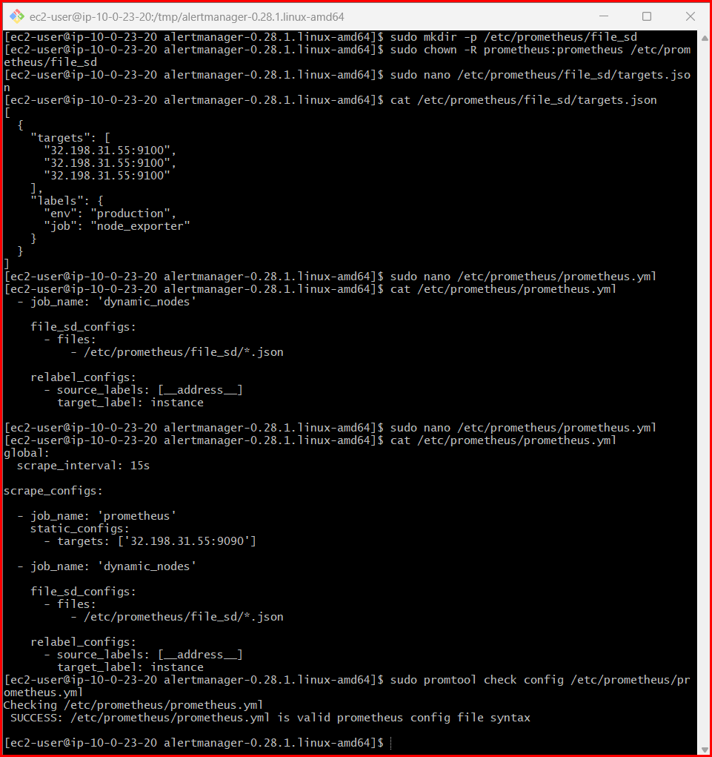

Step 5 — Restart Prometheus
sudo systemctl restart prometheus

Step 6 — Verify Targets
Open:
http://SERVER-IP:9090/targets
You should see:
- localhost:9100
- 192.168.1.20:9100
- 192.168.1.21:9100
All should show:
UP

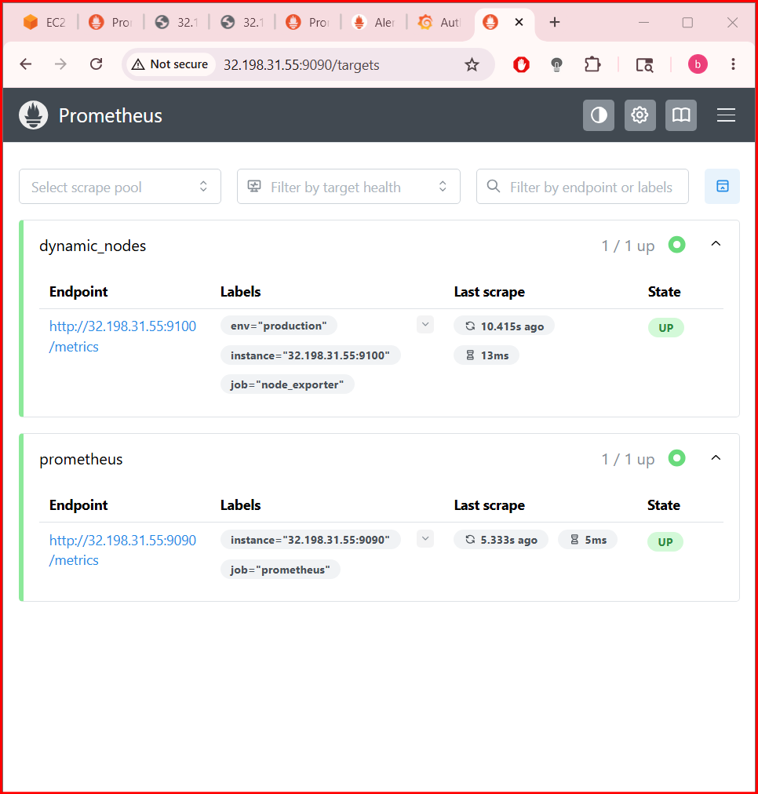

Dynamic Target Updates
Now you can add/remove targets without changing prometheus.yml.
Example:
sudo nano /etc/prometheus/file_sd/targets.json
Add new server:
[
{
"targets": [
"localhost:9100",
"localhost:9100",
"localhost:9100",
"localhost:9100"
],
"labels": {
"env": "production",
"job": "node_exporter"
}
}
]
Prometheus automatically reloads target file.
No restart needed.

EC2 Service Discovery (AWS)
For dynamic Amazon Web Services EC2 instances.
Add to prometheus.yml:
- job_name: "ec2"
ec2_sd_configs:
- region: ap-south-1
port: 9100
relabel_configs:
- source_labels: [__meta_ec2_private_ip]
replacement: '${1}:9100'
target_label: __address__
- source_labels: [__meta_ec2_tag_Name]
target_label: instance

Required AWS Permissions
Your Prometheus server needs IAM permissions:
{
"Version": "2012-10-17",
"Statement": [
{
"Effect": "Allow",
"Action": [
"ec2:DescribeInstances"
],
"Resource": "*"
}
]
}
Attach this IAM role to EC2 instance running Prometheus.

Kubernetes Service Discovery
For Kubernetes:
- job_name: 'kubernetes-pods'
kubernetes_sd_configs:
- role: pod

Docker Service Discovery
- job_name: 'docker'
docker_sd_configs:
- host: unix:///var/run/docker.sock

Useful Queries
Discovered targets:
up
Targets by job:
up{job="dynamic_nodes"}

Verify Active Targets
Open:
http://SERVER-IP:9090/service-discovery
and:
http://SERVER-IP:9090/targets
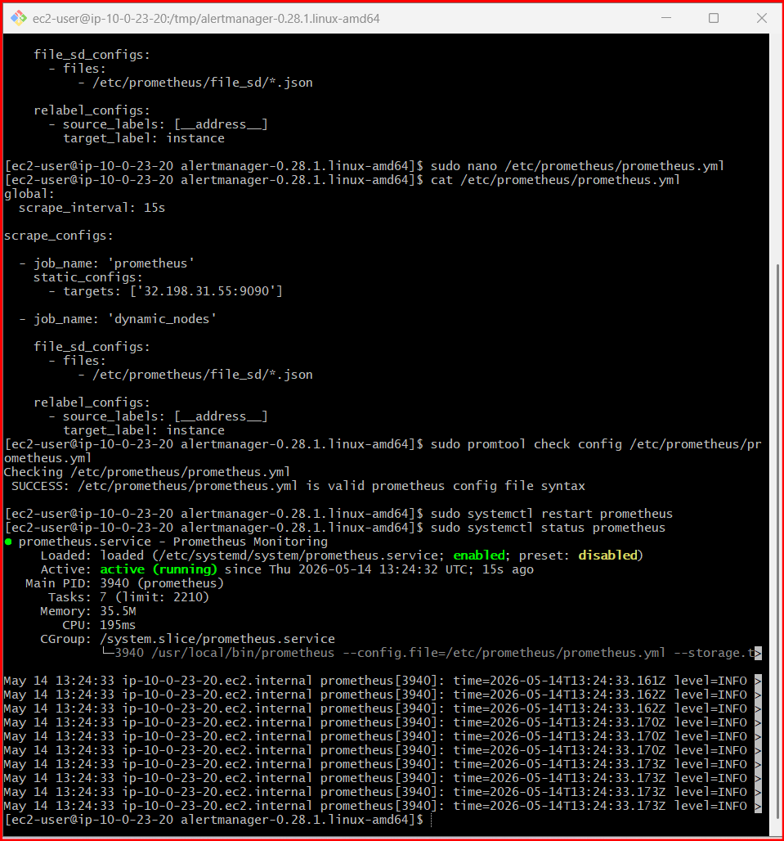

  - Create alerting rules for monitoring disk space.

Step 1 — Create Alert Rules File
Create file:
sudo nano /etc/prometheus/disk-alerts.yml
Paste this configuration:
groups:
- name: DiskSpaceAlerts
rules:
- alert: DiskSpaceWarning
expr: |
(100 - (
node_filesystem_avail_bytes{fstype!="tmpfs"} * 100
/
node_filesystem_size_bytes{fstype!="tmpfs"}
)) > 80
for: 1m
labels:
severity: warning
annotations:
summary: "Disk Space Warning"
description: "Disk usage is above 80% on {{ $labels.instance }}"
- alert: DiskSpaceCritical
expr: |
(100 - (
node_filesystem_avail_bytes{fstype!="tmpfs"} * 100
/
node_filesystem_size_bytes{fstype!="tmpfs"}
)) > 90
for: 1m
labels:
severity: critical
annotations:
summary: "Disk Space Critical"
description: "Disk usage is above 90% on {{ $labels.instance }}"
Save:
- CTRL + O
- Enter
- CTRL + X

Step 2 — Add Rules File in Prometheus
Edit config:
sudo nano /etc/prometheus/prometheus.yml
Add:
rule_files:
- "disk-alerts.yml"

Example Full prometheus.yml
global:
scrape_interval: 15s
rule_files:
- "disk-alerts.yml"
alerting:
alertmanagers:
- static_configs:
- targets:
- localhost:9093
scrape_configs:
- job_name: 'prometheus'
static_configs:
- targets: ['localhost:9090']
- job_name: 'node_exporter'
static_configs:
- targets: ['localhost:9100']

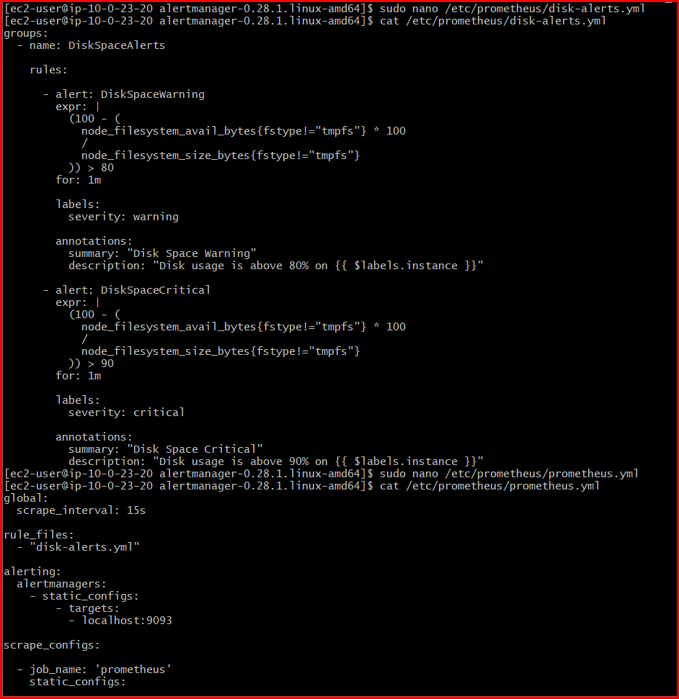

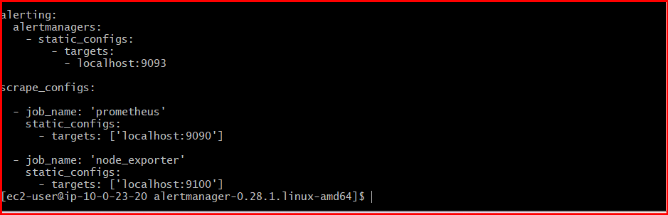

Step 3 — Validate Configuration
Validate Prometheus config:
sudo promtool check config /etc/prometheus/prometheus.yml
Expected:
SUCCESS
Validate rules file:
sudo promtool check rules /etc/prometheus/disk-alerts.yml
Expected:
SUCCESS

Step 4 — Restart Prometheus
sudo systemctl restart Prometheus

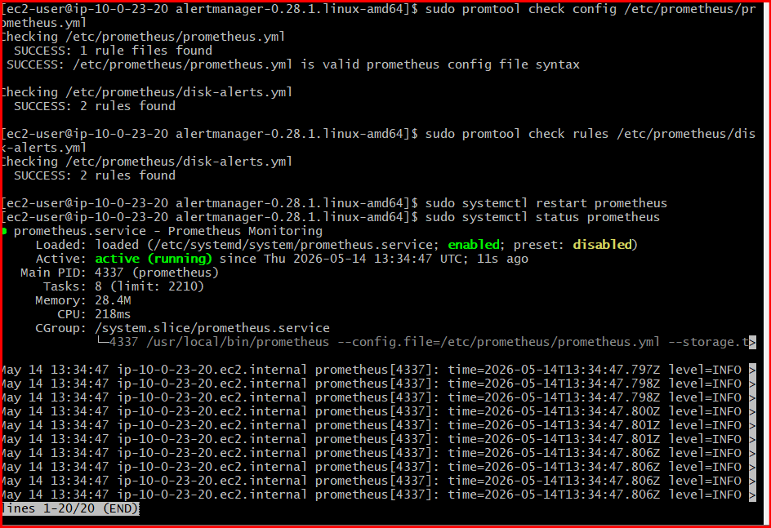

Step 5 — Verify Alert Rules
Open:
http://SERVER-IP:9090/rules
You should see:
- DiskSpaceWarning
- DiskSpaceCritical

Step 6 — Verify Alerts Page
Open:
http://SERVER-IP:9090/alerts
Initially:
Inactive
When disk usage crosses threshold:
Firing

Step 7 — Test Disk Alert
Create a large file to increase disk usage.
Example:
fallocate -l 5G /tmp/testfile
OR
dd if=/dev/zero of=/tmp/testfile bs=1M count=5000
Check usage:
df -h
After 1 minute:
- Alert should fire
- Alertmanager sends email notification

Step 8 — Remove Test File
rm -f /tmp/testfile
Restart alert recovery automatically.

Useful Disk Queries
Disk usage percentage:
100 - (
node_filesystem_avail_bytes * 100
/
node_filesystem_size_bytes
)
Available disk space:
node_filesystem_avail_bytes
Disk usage by mount point:
node_filesystem_size_bytes

Optional: Ignore Docker/Kubernetes Mounts
Improved rule:
expr: |
(
100 - (
node_filesystem_avail_bytes{
mountpoint="/",
fstype!="tmpfs"
} * 100
/
node_filesystem_size_bytes{
mountpoint="/",
fstype!="tmpfs"
}
)
) > 80

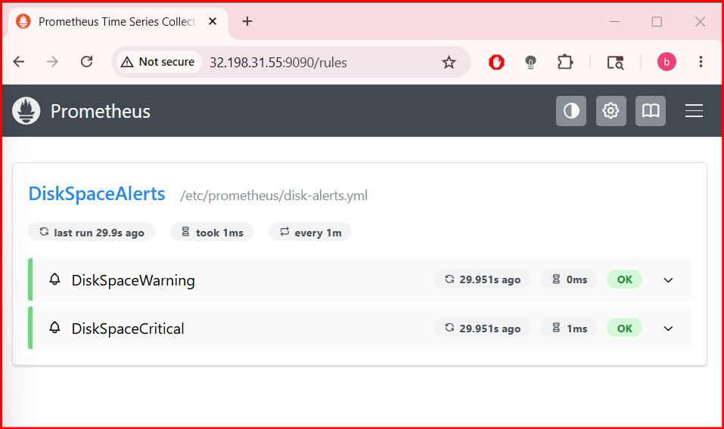

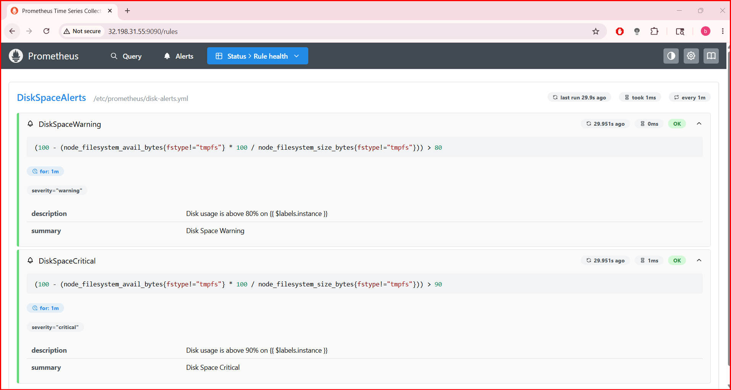

  - Create a custom Grafana dashboard using Prometheus metrics for specific insights.

Step 1 — Open Grafana
Open browser:
http://SERVER-IP:3000
Login:
Username: admin
Password: admin

Step 2 — Create New Dashboard
In left sidebar:
- Click ➕ Create
- Click Dashboard
- Click:
Add visualization
Choose data source:
- Prometheus

Step 3 — Create CPU Usage Panel
Panel title:
CPU Usage %
Prometheus query:
100 - (avg by(instance) (rate(node_cpu_seconds_total{mode="idle"}[5m])) * 100)
Visualization:
- Time Series
Click:
Apply

Step 4 — Create Memory Usage Panel
Click:
Add Panel
Panel title:

